Airline Reservation System

1. **Creating the tables.**

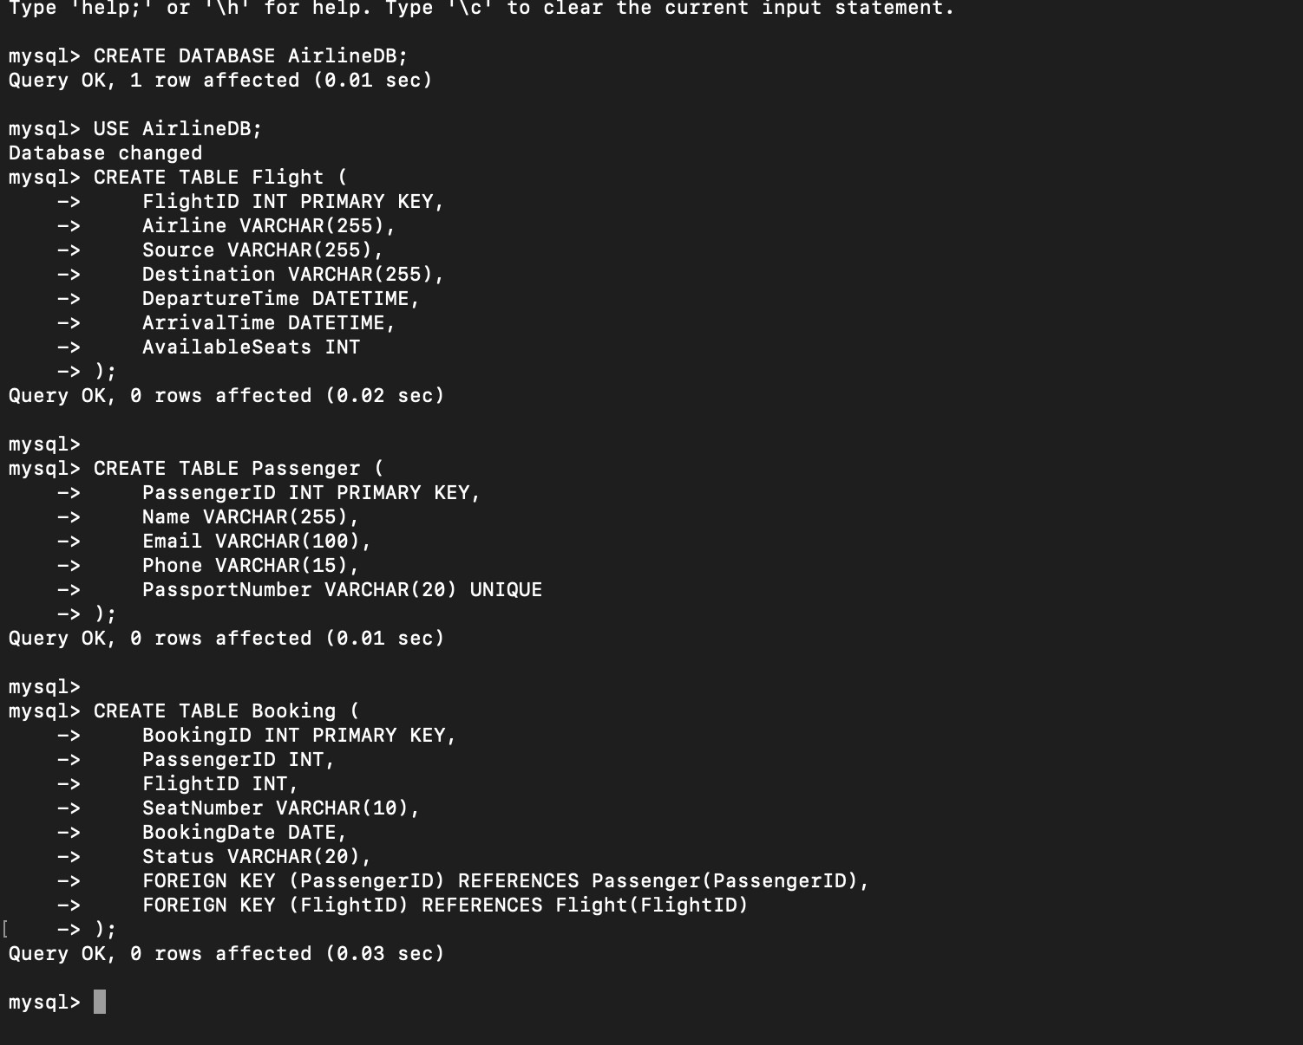

1. **Inserting data.**

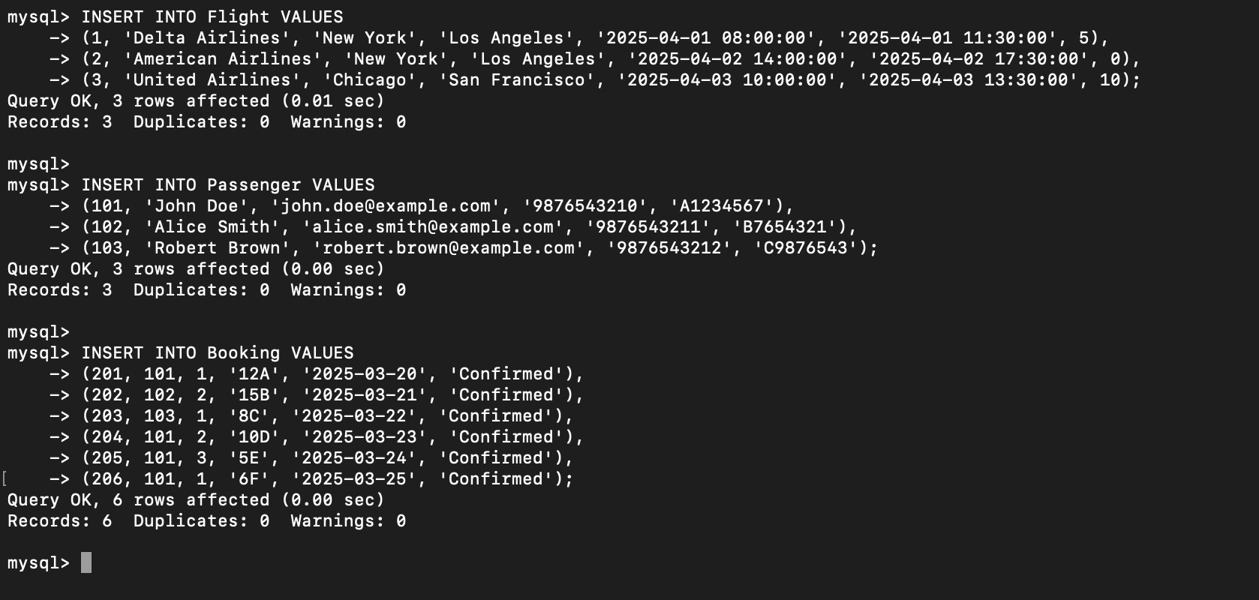

1. **Retrieve flights available from “New York” to “Los Angeles”.**

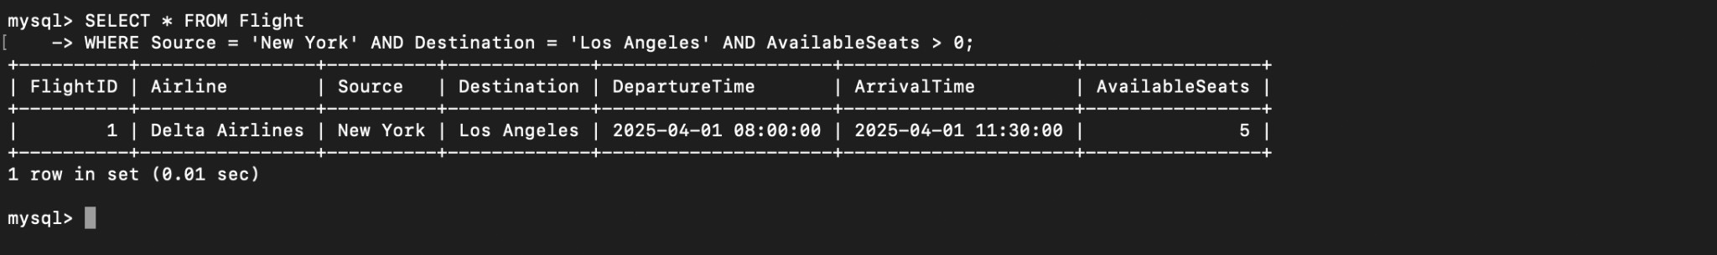

1. **Find passengers who have booked more than 3 flights.**

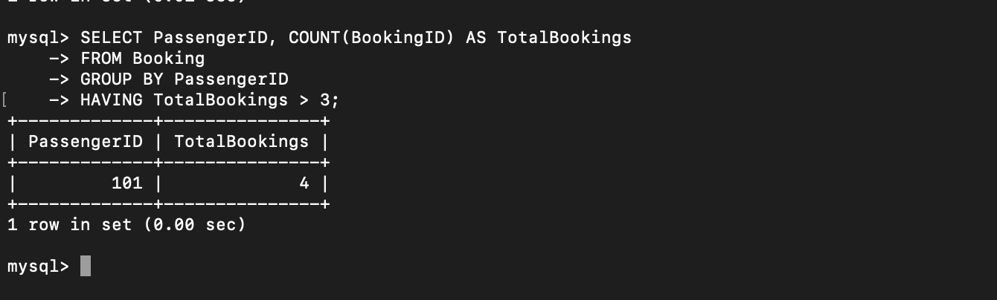

1. **Retrieve details of flights departing within the next 24 hours.**

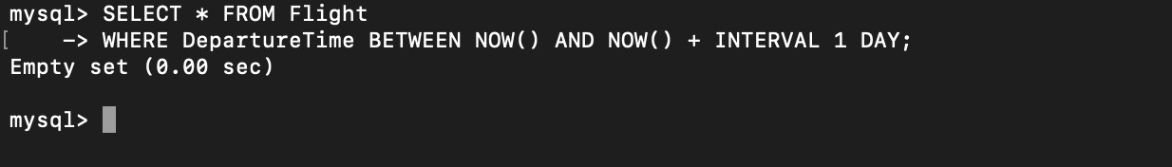

1. **Display total bookings per flight.**

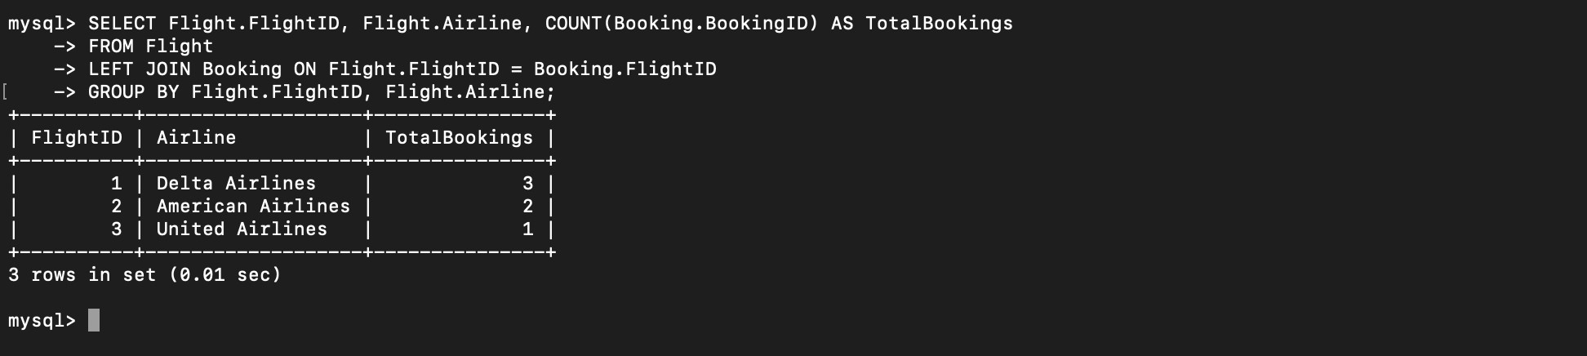

1. **Find flights that are fully booked.**

